# Travelling Website

Submitted in partial fulfilment of the requirements

of the degree

# BACHELOR OF ENGINEERING IN INFORMATION

**TECHNOLOGY**

By

# Rohan Surve (57)

# Abhishek Singh (55)

**Gaurav Takalkar (59)**

**Sangam Prajapati (42)**

Supervisor

**Prof. Priyanka Sananse**



# Department of Information Technology

**K C College of Engineering and Management Studies and Research Mith Bunder Road, Near Hume Pipe, Kopri, Thane (East)**

# University of Mumbai (AY 2022-23)

This is to certify that the Mini Project entitled **“Travelling Website”** is a bonafide work of **Rohan Surve (57), Abhishek Singh (55), Gaurav Takalkar (59), Sangam Prajapati (42).** submitted to the University of Mumbai in partial fulfillment of the requirement for the award of the degree of **“Bachelor of Engineering”** in **“Information Technology”.**

Name and sign Name and sign

Supervisor/Guide Co Supervisor/Guide



Name and sign Name and sign

Head of Department Principal

This Mini Project entitled “**Travelling Website”** by **Rohan Surve (57), Gaurav Takalkar (59), Abhishek Singh (55), Sangam Prajapati (42).** is approved for the degree of **Bachelor of Engineering** in **Information Technology.**

**Examiners**

**1………………………………………**

(Internal Examiner Name & Sign)

### 2…………………………………………

(External Examiner name & Sign)

Date:

Place

### Declaration

We declare that this written submission represents our ideas in our own words and where others' ideas or words have been included, we have adequately cited and referenced the original sources. We also declare that we have adhered to all principles of academic honesty and integrity and have not misrepresented or fabricated or falsified any idea/data/fact/source in my submission. We understand that any violation of the above will be cause for disciplinary action by the Institute and can also evoke penal action from the sources which have thus not been properly cited or from whom proper permission has not been taken when needed.

Name of the student and Roll no. Signature

1)Rohan Surve (57)

2)Abhishek Singh (55)

3)Sangam Prajapati (42)

4)Gaurav Takalkar (59)

Date:

Place:

# Contents

Abstract ii

Acknowledgments iii

1. Introduction 01
   1. Introduction
   2. Motivation
   3. Problem Statement & Objectives
   4. Organization of the Report

## Literature Survey 03

* 1. Survey of Existing System
  2. Limitation Existing system or research gap
  3. Mini Project Plan & Contribution

|  |
| --- |
| 1. **Proposed System 06**    1. Introduction    2. Architecture/ Framework    3. Algorithm and Process Design    4. Details of Hardware & Software    5. Experiment and Results    6. Conclusion and Future work. |
| **References 28** |

# Abstract

The purpose of Travelling Website is to automate the exiting manual system by the

Help of Computerized equipment and fill-fledged Website, fulfilling their requirements, so that their valuable data/information can be stored for a longer period with easy accessing and manipulation of the same. The required software and hardware are easily and easy to work with.

Travelling Website, as described above, can lead to error free, secure, reliable and fast booking Website. It can assist the user to concentrate on their other activities rather to concentrate on the record keeping. Thus it will help organization in better utilization of resources. The organization can maintain computerized records without redundant entries. That means that one need not be distracted by information that is not relevant, while being able to reach the information.

The aim is to automate its existing manual system by the help of computerized equipment and Full-fledged computer website, fulfilling their requirements, so that their valuable data/information can be stored for a longer period with easy accessing and manipulation of the same. Basically the project describes how to manage for good performance and better services for the clients.

This project has been developed to carry out the processes easily and quickly, which is not possible with the manuals systems, which are overcome by this software. This project is developed using HTML, CSS, NODE.JS and MONGODB use for database connection. Creating and managing requirements is a challenge of IT, systems and product development projects or indeed for any activity where you have to manage a contractual relationship. Organization need to effectively define and manage requirements to ensure they are meeting needs of the customer, while proving compliance and staying on the schedule and within budget. The impact of a poorly expressed requirement can bring a business out of compliance or even cause injury or death. Requirements definition and management is an activity that can deliver a high, fast return on investment.

# ACKNOWLEDGMENTS

The austerity and satisfaction that one gets on completing a project cannot be fulfilled without mentioning the people who made it possible.

We are privileged to express our sincere gratitude to honorable **Dr. Vilas Nitnaware**, Principal, KCCEMSR for all encouragement he gave us. We express our sincere thanks and gratitude to **Prof. Amarja Adgaonkar** (H.O.D.) of IT department for all her valuable suggestions and guidance throughout our project.

We wish to express our hearty gratitude to our internal project guide, **Prof. Seema Bhuravane**

for her valuable suggestions and guidance throughout the tenure of our project.

Rohan Surve 57

Abhishek Singh 55

Sangam Prajapati 42

Gaurav Takalkar 59

* 1. **Introduction**

# INTRODUCTION

Travel Management is a process of organizing and booking tickets,for a particular target audience. It involves visualizing concepts, planning, budgeting, and booking of Hotels, Flights, Trains, Buses, etc. Travelling Website is a multi-million dollar industry, growing rapidly, with booking of tickets regularly. Surprisingly, there is no formalized research conducted to access the growth of this industry. The modern traveller's journey begins on the internet, where they seek information, inspiration, and a seamless platform to plan their trips. Recognizing this, our project focuses on the development of a comprehensive Traveling Website to cater to the needs of travellers worldwide.

Travelling Website is the project for the booking and management of Tickets and providing the information to the users about the location they want to explore. The process of planning and Booking for hotels and trains is usually referred to as Trip planning and which can include budgeting, scheduling, site selection, acquiring necessary permits, coordinating transportation and parking, or Hotels arranging events, Flights, coordinating with third party agents, and emergency plans. The Travelling industry now includes trips of all sizes from the Domestic to business meetings trips The Traveling Website project seeks to embrace this digital evolution and elevate the travel experience to new heights. It aims to provide a comprehensive solution for travellers, helping them from the moment the travel bug bites to the moment they return home. Our project focuses on delivering a user-centric platform that serves as a one-stop hub for travel information, planning, bookings, and community engagement.

There are mainly 2 types of Travelling Websites:

* Domestic Travel Websites
* International Travel Websites

## 1.2Motivation

The objective of this website is to develop a system that effectively manages all the data related to the various travel that take place by a person. The purpose is to maintain a centralized database of all event related information. The goal is to support various functions and processes necessary to manage the data efficiently.

## In the fast paced world today there is a great need of online social networking facilities. Thus the benefits of this project in the current scenario make it economically feasible. The purpose of the economic feasibility assessment is to determine the positive economic benefits to the organization that the proposed system will provide. It includes quantification and identification of all the benefits expected. This assessment typically involves a cost/benefits analysis.

## 1.3 Problem Statement & Objectives

Problem- Every Tour Management their scheduling and selling tickets are very challenging for organizer, whether big or small, has challenges to overcome and managing the every tour.

Solution- Travelling Website has different person needs, so we design exclusive Travelling Website. This is designed to assist in strategic planning and it will help to ensure that the person is equipped with the right level of information and details of your future goals. Also for those busy executive who are always on the go, Our system come with remote access features, which will allow you to manage your workforce anytime. These system will ultimately allow you to better manage resources.

**Objectives**

The main objective of our project is providing the different typed of customers facility, the main objective of this system is to find out the actual customer service. Etc.

It should fulfill almost all the process requirements of any tour

* Improve Customer Service. Every scheduling department's top priority must be ensuring that trip meet the expectations of organizers and attendees. ...
* Increase Operational Efficiency. ...
* Grow Revenue. ...
* Optimize Facility Utilization. ...
* Increase Safety.
* Give proper tour data

## 1.4 ORGANIZATION OF REPORT

* The report is divided into 3 parts explain the project.
* The first chapter gives the introduction of project as well as our motivation behind selecting the project as well the problem statement of project.
* The second chapter gives the overview on the literature survey conducted by the team.
* Survey of existing system, limitations of literature survey and the implementation plan of the project are also explained in the chapter
* Final chapter explains the framework on which the project is made as well as shows outputs of our project.
* Finally, we have the page elaborating conclusion and future scope of the project.

# 2. LITERATURE SURVEY

## Survey of Existing System

In the existing system the transactions are done only manually but in proposed system we have to computerize all the banking transaction using the software Banking system.

|  |  |  |  |  |
| --- | --- | --- | --- | --- |
| Sr. No | Title of Paper/ Website | Methodology used | Advantages | Limitations/ Challenges |
| 1 | TripAdvisor | Global platform that offers traveler’s review, ratings and recommendations for hotels, flights and attractions. | It serves as a trusted resource for travelers seeking information and feedback from other tourists. | Do not provide booking Services. |
| 2 | **Booking.com** | one of the largest online travel agencies, providing users with an extensive database of hotels, vacation rentals, and other lodging options. | It offers a user-friendly platform for booking accommodations, often with flexible cancellation policies and competitive pricing. | Inaccuracy |
| 3 | **Google Travel** | offers a suite of travel-related tools, including Google Flights and Google Maps, that help users search for flights, hotels, and local attractions. | These tools provide valuable information for planning trips. | Inefficient prediction. |

## Limitation Existing system or research gap

* Lack of security of data.
* More man power.
* Time consuming.
* Consumes large volume of pare work.
* Needs manual calculations.
* No direct role for the higher officials.
* Damage of machines due to lack of attention. To avoid all these limitations and make the working more accurately the system needs to be computerized.

## MINI PROJECT IMPLEMENTATION PLAN

* In the first week we planned our mini project which includes finalization of topic, problem statement and the platform on which project is to be made.
* After planning, our team did a literature survey of our topic where we noticed the flaws in current system and how we can overcome them.
* Then we started designing GUI of our project. Accordingly we made our flowchart and class diagram.
* Then after that different frames were divided among the group members and certain timeline was given to complete the task.
* The database part was also done simultaneously. After completion of coding part of each individual member, testing and debugging was done and the project was complete.

**The above implementation plan can be Pictorially represented with the help of figures below:**

* Abhishek Singh :- Code Implementation
* Rohan Surve:- Design, Clearing errors, creating PPT
* Gaurav Takalkar :-Final Executation of project and preparing the report

# 3.PROPOSED SYSTEM

## Introduction

Here in our project there are one type of module. This module is the main module which performs all the main operations in the system. The major operations in the system are:

## User Module

1. User can access this project there is an authorization process. When you login as an User then you will be redirected to the Main WebSite Page. This performs the following functions: User login, View Destinations , View Ticket, View Event, Cancel ticket etc.
2. User login
3. View Destinations
4. Book Tours
5. Read Blogs
6. Book Packages
7. Cancel Us

## Architecture/ Framework

The front end /GUI part of project is made on HTML5,CSS and JavaScript and ide used is Vs Code. The Backend code is written in NodeJs and Database is Connected With MongoDB Database.

There are 7 Pages in total in project namely:

* Main Page
* Signin Page
* Signup Page
* Contact-Us Page
* Booking Page
* View Destination Info Page
* About-Us Page

## Algorithm and Process Design

### Flow Diagram:-

### 

**Alogorithm:-**

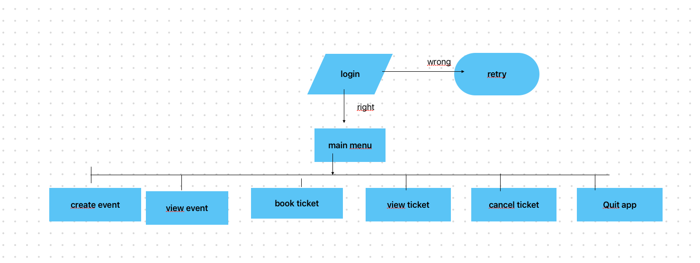

# Details of Hardware & Software

## Hardware Requirements Specification

* Processor : Intel Pentium III or later
* Main Memory(RAM) : 256 MB Cache Memory : 512 KB
* Monitor : 14 inch Color Monitor
* Keyboard : 108 Keys
* Mouse : Optical Mouse
* Hard Disk : 160 GB

**Software Requirements Specification**

* Front End/Language : HTML5,CSS,JavaScript
* Back End/Database : Mongodb,NodeJs.
* Additional Tools : Visual Studio Code,MongoDB Compass
* Operating System : Windows 7, 8, 9, 10, XP

# Experiment and Results

There are 7 Frame in total in project namely:

* Main Page
* Signin Page
* Signup Page
* Contact-Us Page
* Booking Page
* View Destination Info Page
* About-Us Page

For reference the code snippets of the project are given below as well as the snippets of entire GUI and database output of the project.

## CODE SNIPPETS

**Fig 1.1** CODE SNIPPET FOR MAIN MENU PAGE :-

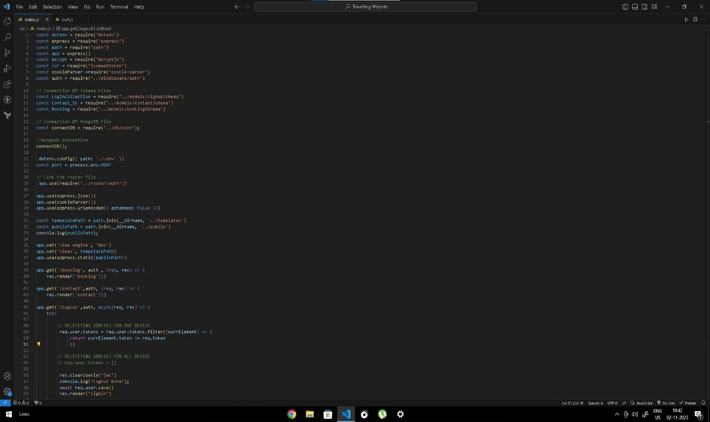

**Fig 1.2** CODE SNIPPET FOR BOOKING TICKET PAGE:-

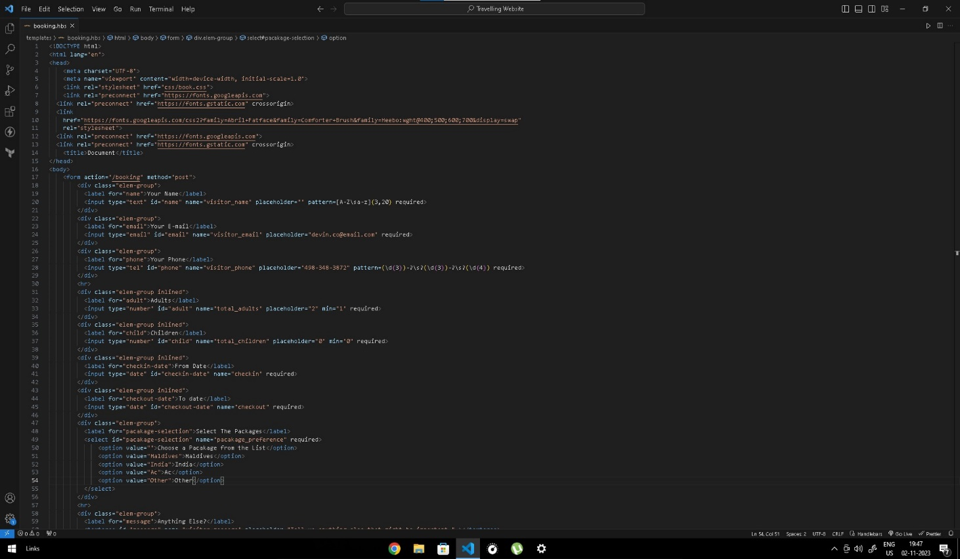

**Fig 1.3** CODE SNIPPET OF CONTACT US PAGE:-

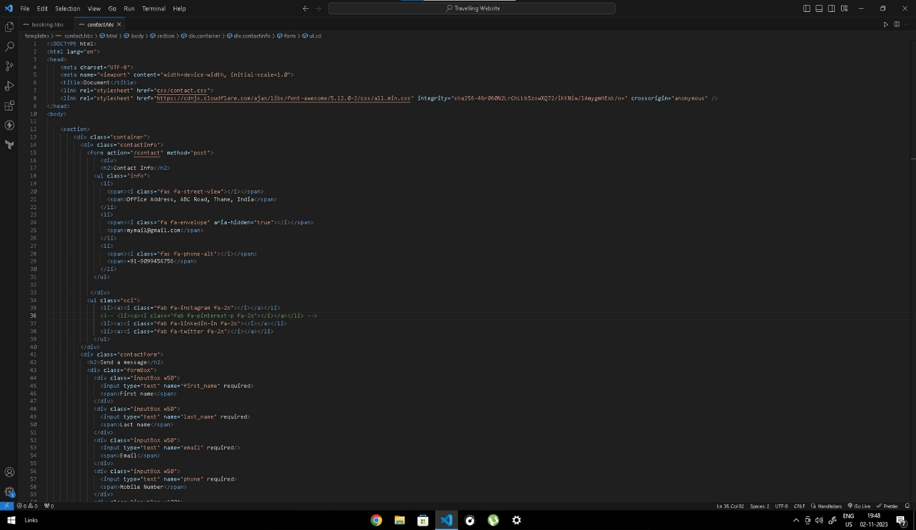

**Fig 1.4** CODE SNIPPET FOR CSS FIELDS:-

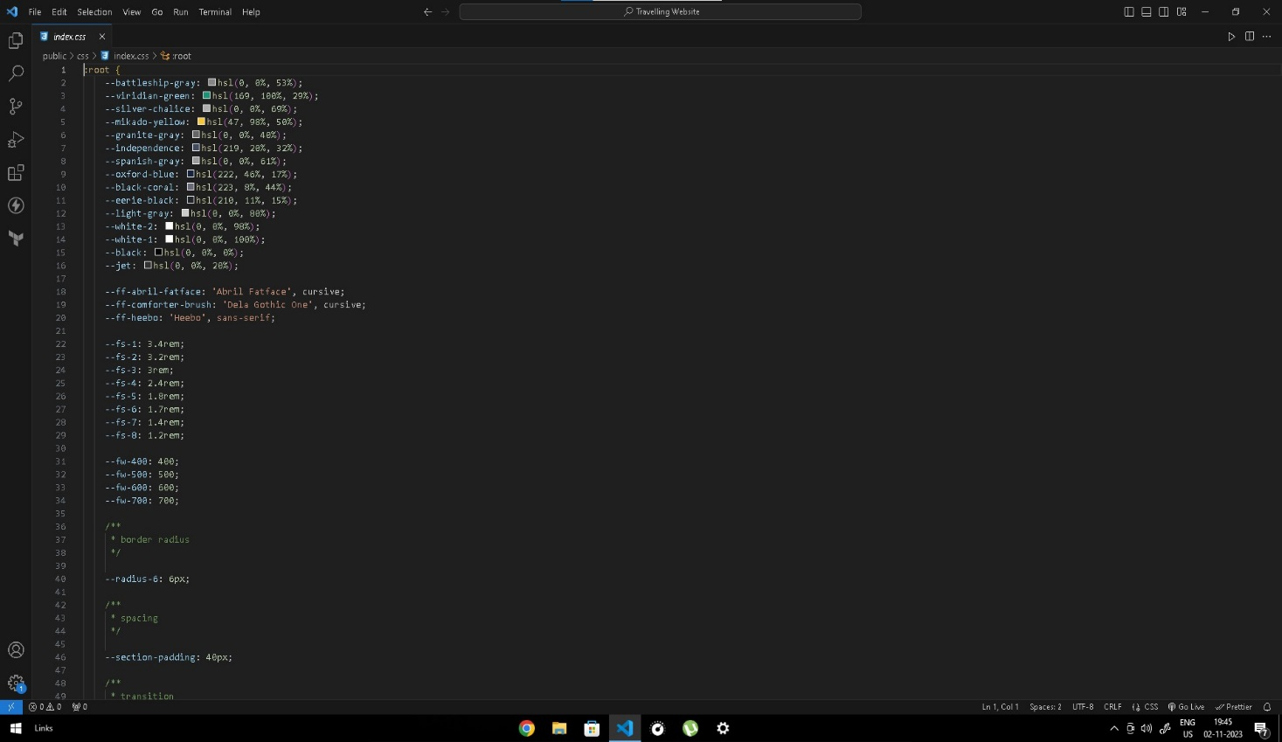

**Fig 1.5** CODE SNIPPET FOR DATABASE:-

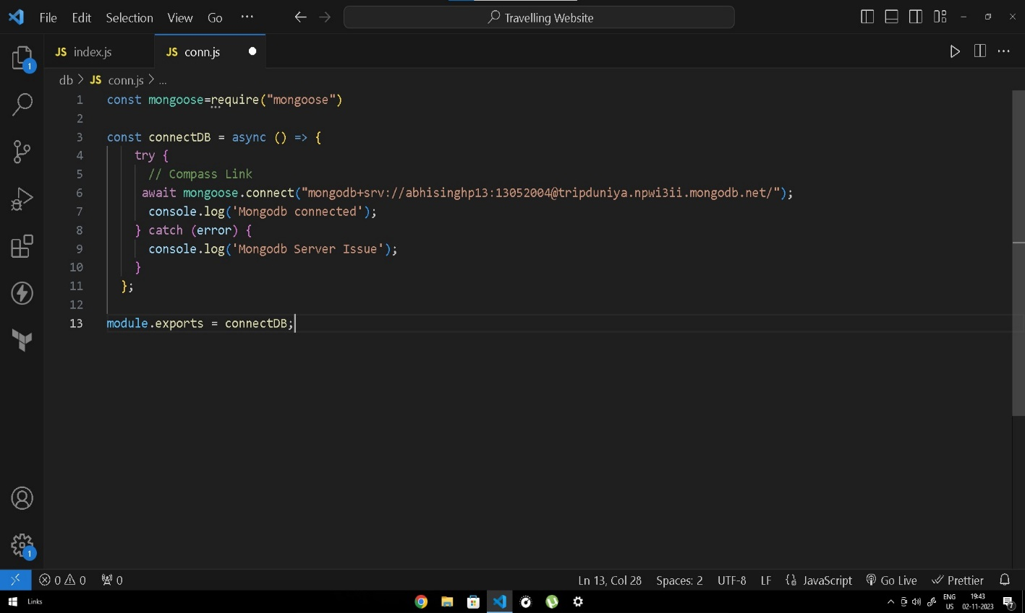

**Fig 1.6** CODE SNIPPET FOR LOGIN INDEX PAGE:-

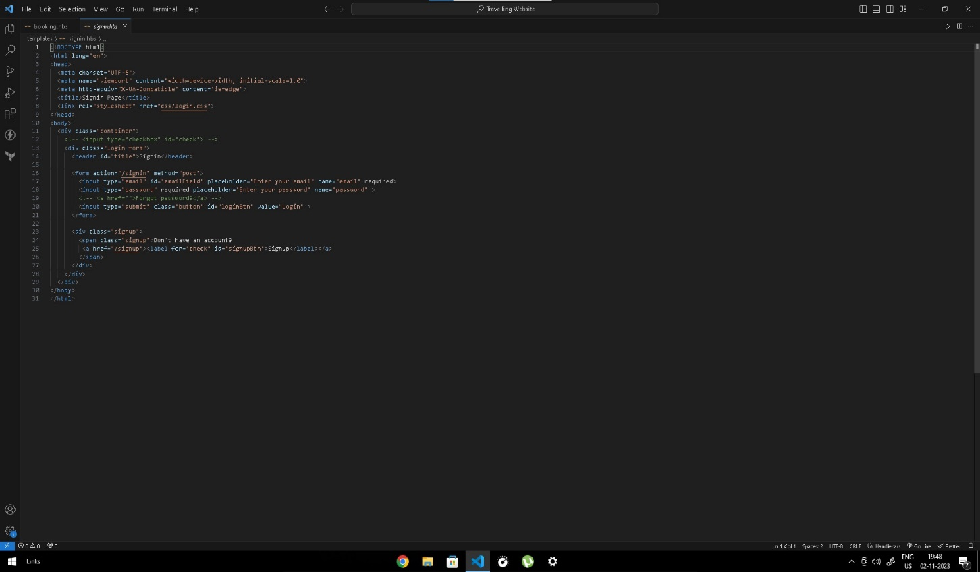

**Fig 1.7** CODE SNIPPETS FOR SIGN UP PAGE :-

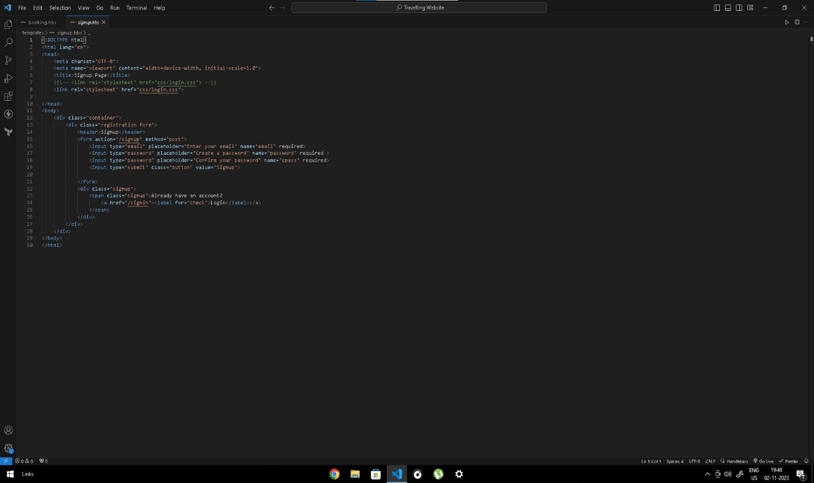

**Fig 1.8** CODE SNIPPETS FOR MIDDLEWARE PAGE :-

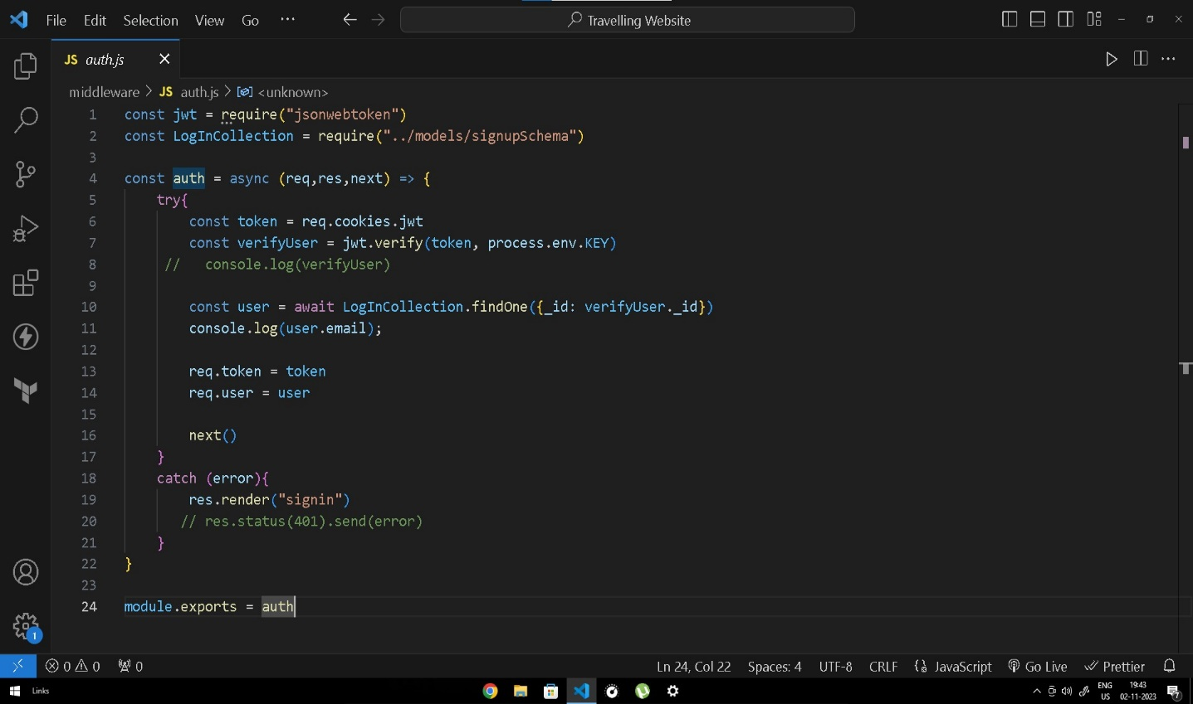

**Fig 1.9** CODE SNIPPETS FOR CONTACT US SCHEMA :-

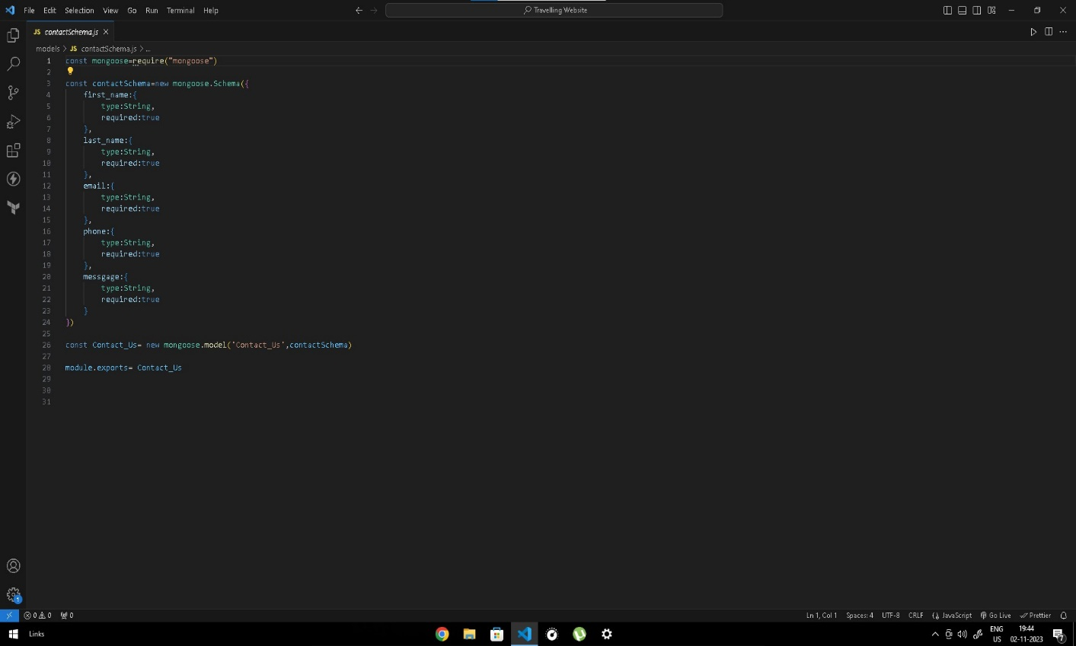

**GUI SNIPPETS OF PROJECT**

**Fig 2.1 Login Page:-**

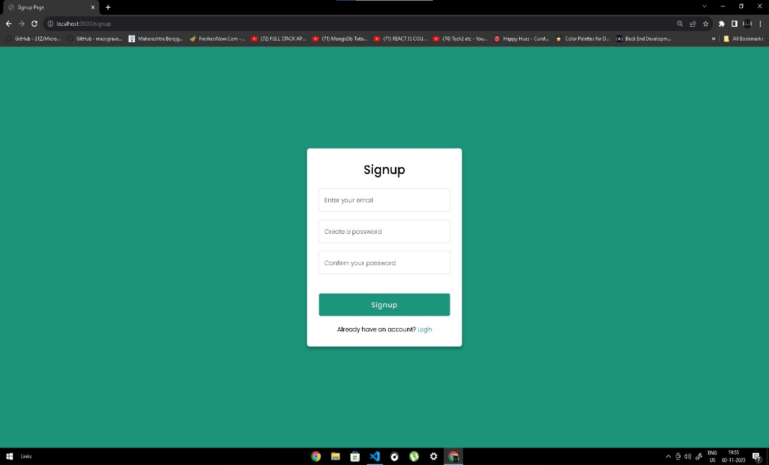

**Fig 2.2** Main Page:-

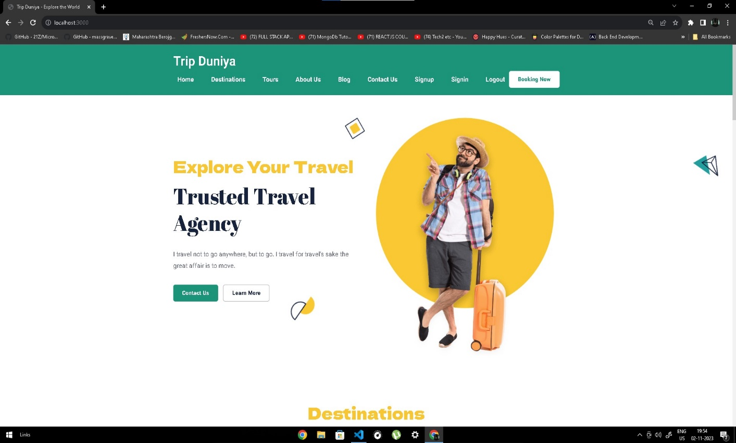

**Fig 2.3** Destination Page:-

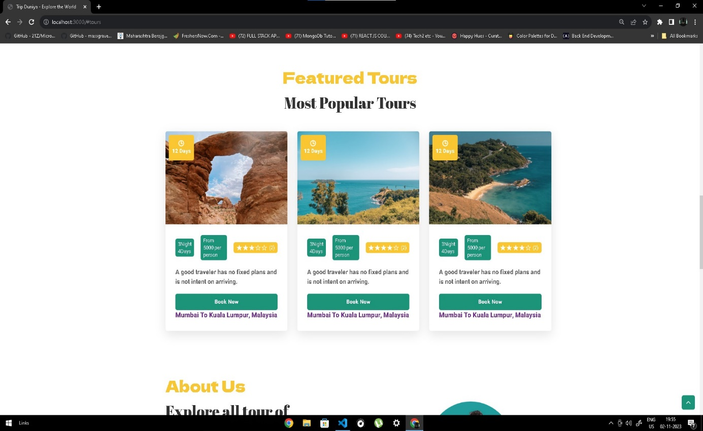

**Fig 2.4** Booking Page:-

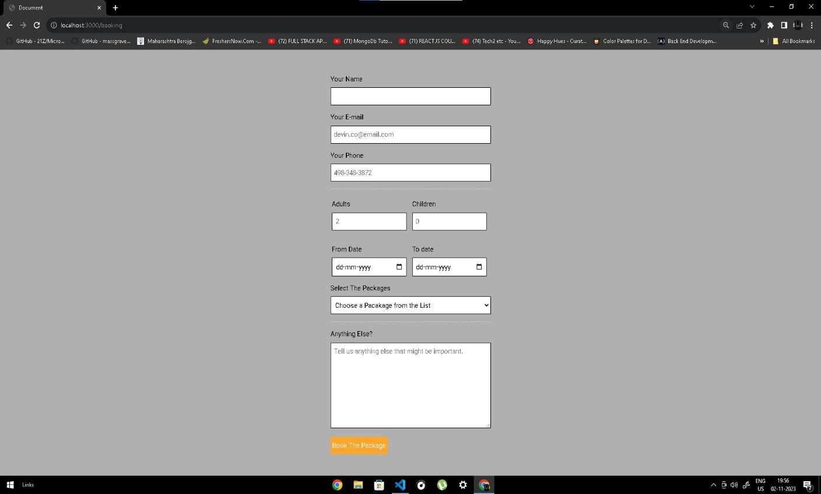

**Fig 2.5** Contact Us Page:-

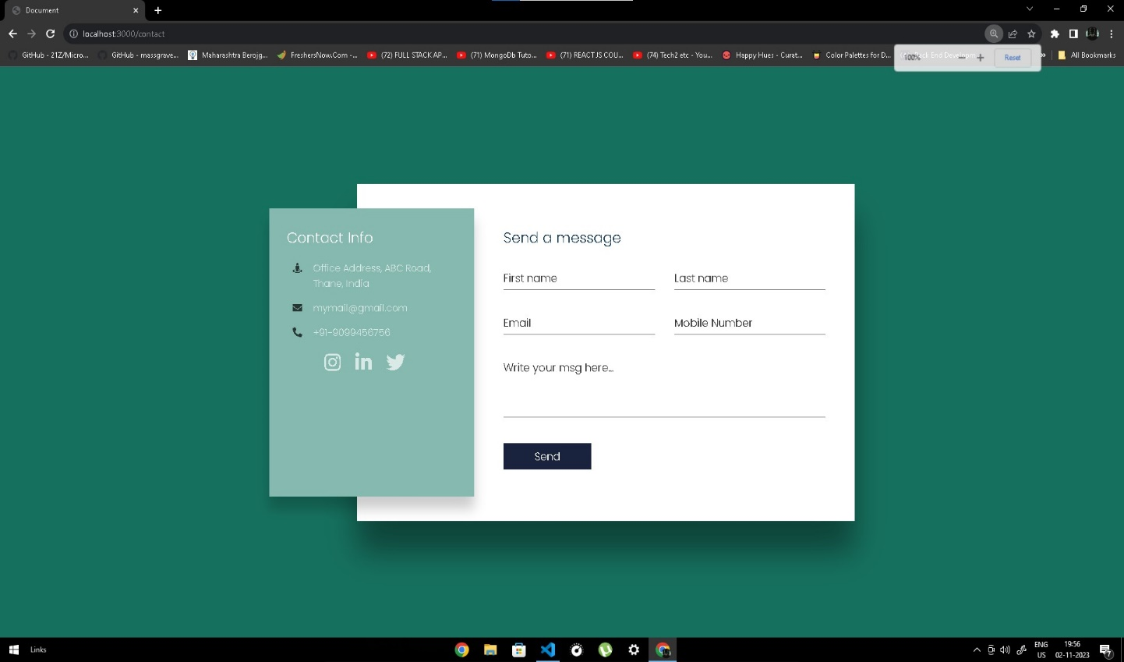

**Fig 2.6** Tour Page:-

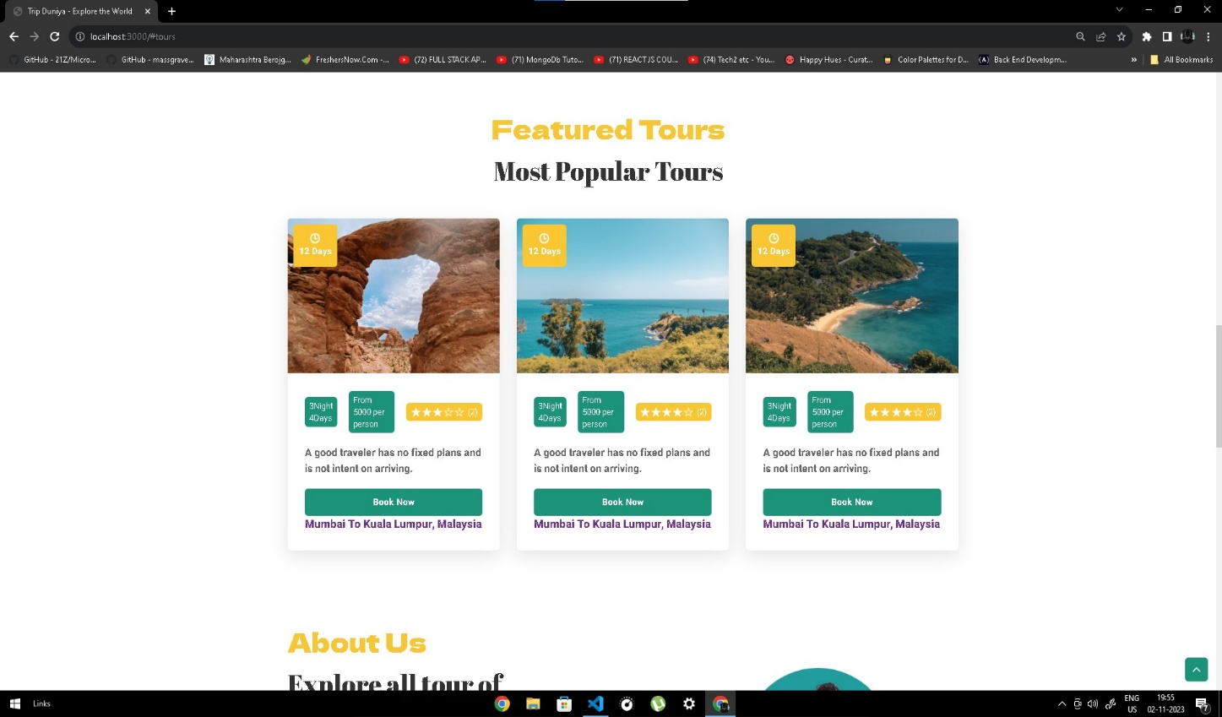

**DATABASE SNIPPETS**

**Fig 3.1** Login DB:-

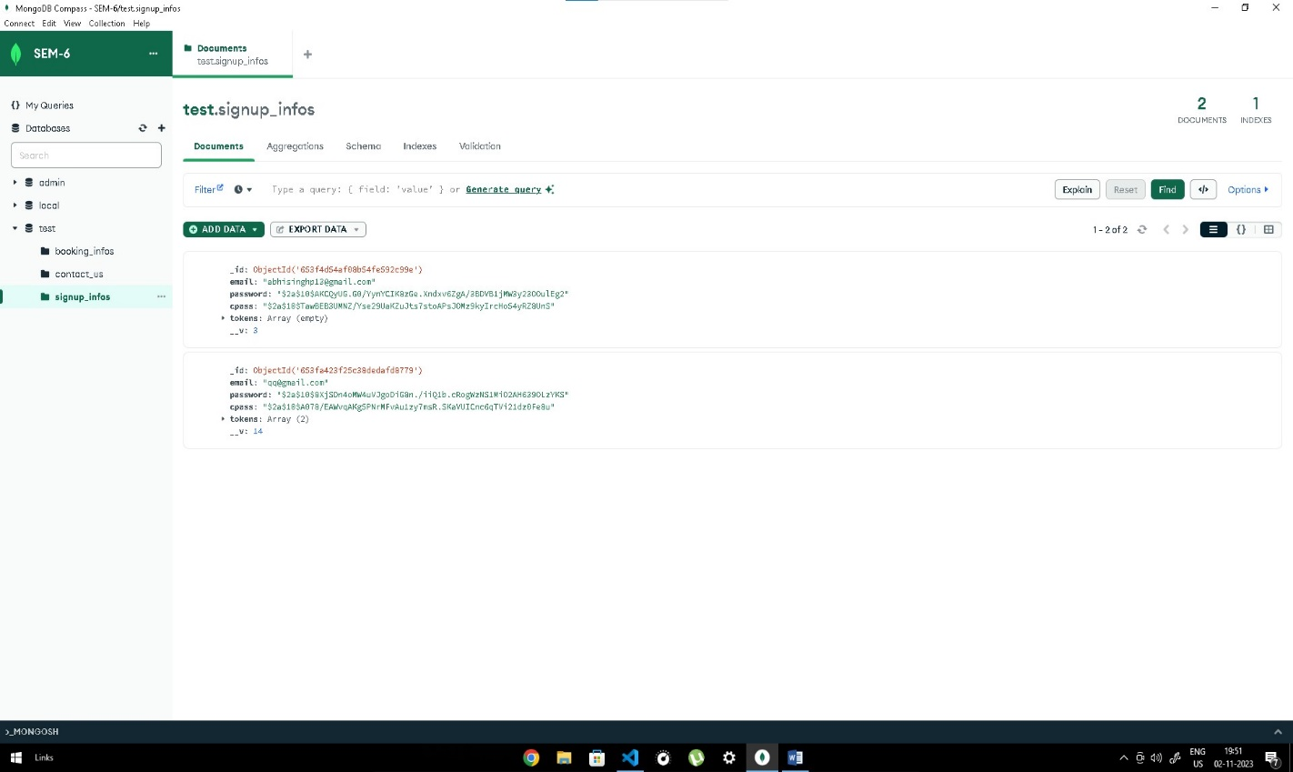

**Fig 3.2** Booking DB:-

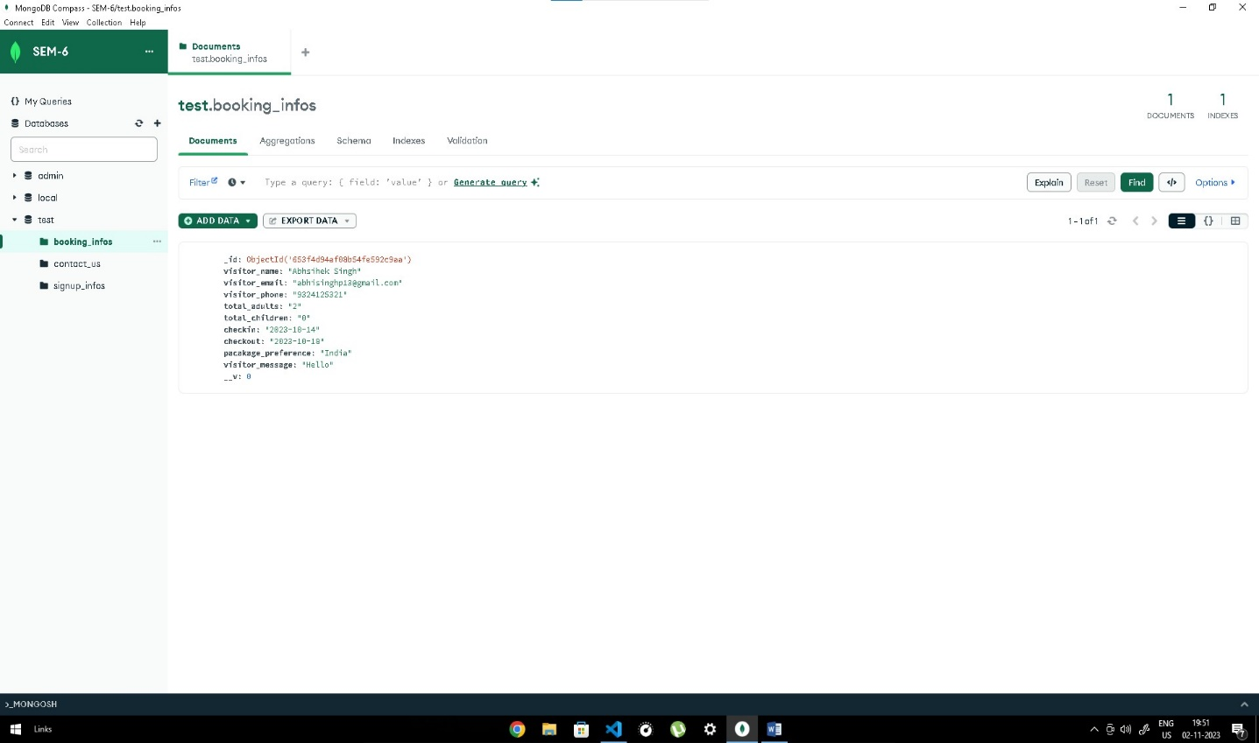-

## Conclusion and Future work

## Our project is only a humble venture to satisfy the needs to manage their project work Several user friendly coding have also adopted. This package shall prove to be a powerful package in satisfying all the requirements of the school .The objective of software planning is to provide a frame work that enables the manager to make reasonable estimate made within a limited time frame at the begining of the software project and should be updates regulary as the project progresses.

## A description of the background and context of the project and its relation to work already done in the area.

## Made statement of the aims and objectives of the project.

## The description of Purpose, Scope, and applicability.

## We define the problem on which we are working in the project.

## We describe the requirement Specifications of the system and the actions that can be done on these things.

## We understand the problem domain and produce a model of the system, which describes operations that can be performed on the system.

## We included features and operations in detail, including screen layouts.

## We designed user interface and security issues related to system.

## Finally the system is implemented and tested according to test cases.

## Future work

## Creating a website that offers information about great destinations, the best hostel deals, and nearby attractions is a fantastic idea. To make it successful, you'll need to plan and execute the development process carefully. Here are some steps and considerations to help you get started:

## Market Research and Concept Development :Identify your target audience and understand their travel preferences. Research destinations and compile information about them. Explore competitors in the travel industry to find your unique selling points.

## Website Planning: Define the website's structure, including pages for destinations, hostels, and attractions. Plan the user interface (UI) and user experience (UX) design. Decide on the technologies and platforms you'll use for development.

## Content Creation:Write high-quality, engaging content about the destinations, hostels, and attractions.Use high-resolution images and videos to make the content visually appealing.

## Website Development: Hire experienced web developers and designers. Develop the website according to your plan, ensuring it's user-friendly, responsive, and secure. Implement a search and filtering system to show content based on user interests.

## Payment System:Choose a reliable payment gateway to handle transactions securely.Ensure the payment system complies with relevant security standards, such as PCI DSS.Test the payment system thoroughly to identify and fix any issues.

# REFERENCES

1. https://en.wikipedia.org/wiki/Travel_website
2. https://www.tripclap.com/?source=google_tp&gad_source=1&gclid=Cj0KCQjwy4KqBhD0ARIsAEbCt6gu2Uvlxi9-l1NjQSKK6V4u0-5X93HOgKK8um8tz-q53VMumep47BUaAvWJEALw_wcB
3. https://www.slideshare.net/ravindrachaudhary3110/tour-and-travel-management-system
4. <https://www.sciencedirect.com/science/article/pii/S2214716022000069>
5. https://stackoverflow.com/questions/36040782/how-to-connect-html-page-with-nodejs
6. <https://www.youtube.com/watch?v=_lLz56gRYe4&list=PLu0W_9lII9agiCUZYRsvtGTXdxkzPyItg&index=81&t=891s&ab_channel=CodeWithHarry>
7. <https://www.youtube.com/watch?v=XZiFBlfluZk&list=PLZccNvBo19r11DwBazcAx6qv9rbelSNLN&index=9&t=904s&ab_channel=ThapaTechnical>
8. <https://www.worldpackers.com/articles/best-travel-blogs#:~:text=Tales%20of%20Backpacker&text=It%20is%20written%20by%20Claire,destinations%20and%20different%20travel%20topics>.
9. <https://www.youtube.com/playlist?list=PLwGdqUZWnOp3t3qT7pvAznwUDzKbhEcCc>
10. <https://www.youtube.com/playlist?list=PLwGdqUZWnOp1P9xSsJg7g3AY0CUjs-WOa>